Log Normal Distribution:

Definition: In probability theory, a log-normal (or lognormal) distribution is a continuous probability distribution of a random variable whose logarithm is normally distributed. Thus, if the random variable X is log-normally distributed, then Y = ln(X) has a normal distribution. Equivalently, if Y has a normal distribution, then the exponential function of Y, X = exp(Y), has a log-normal distribution.

X $∈$ Log Normal Distribution($μ, σ$)

If we apply a transformation calculating a random variable Y such that Y = ln(X)

Ln -> Natural log = $\log_{e}$

This Y will belong to a normal distribution.

This needs to be done as many machine learning algorithms expect the data to be in normal distribution.

Equivalently, if Y = ln(X),

We can define X which is a random variable, such that X = exp(Y)

Then X is log normally distributed.

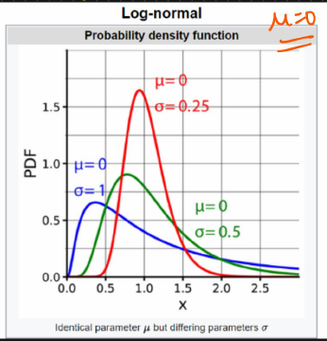

Mean is constant.

Log normal distribution is a right skewed distribution as the right hand side is always elongated.

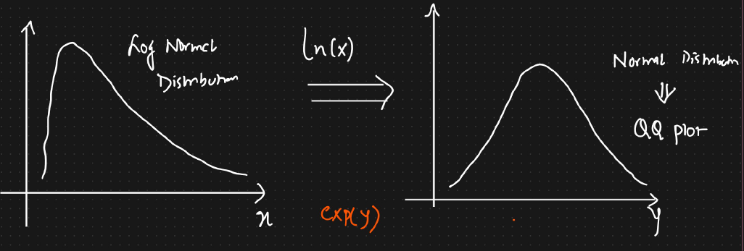



To check whether a given distribution is normal distribution or not, we apply QQ plot.

Example:

1. Wealth distribution of the world

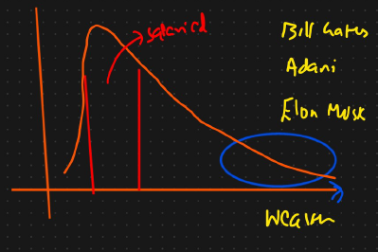

2. Discussion forum: Length of the comment. Most people write smaller comments.

3. Length of chess game.

4. Dwell time or time spent on online articles